
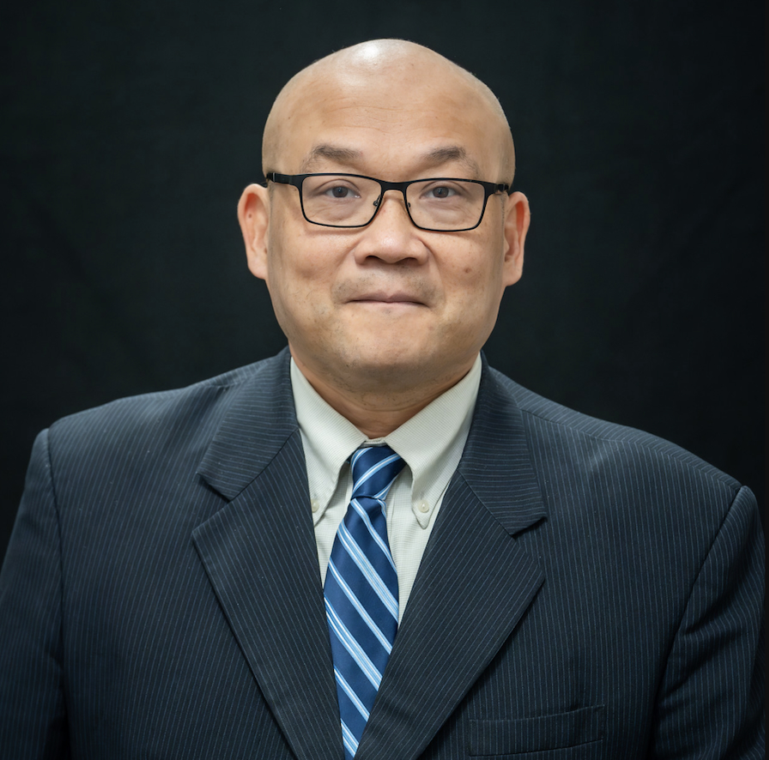 | JEENCHEN "ROBERT" CHEN, MD, MPH  Columbus, Ohio | 949-247-1058 | robert.chen@medlegalpro.com

Areas of Expert Practice: Nursing Home & Skilled Nursing • Correctional Medicine • Family / Internal Medicine

PROFESSIONAL SUMMARY
Physician with extensive experience in clinical medicine, healthcare technology, academic medicine, and multidisciplinary patient care. Active physician currently practicing in skilled nursing facilities, correctional medicine, and as an Independent Medical Examiner for the Social Security Administration. Trained in internal medicine, cardiovascular surgery, critical care, heart and lung transplantation, and mechanical circulatory support. Harvard-trained in public health quantitative methods. Author of more than 90 peer-reviewed publications and reviewer/editor for multiple international medical journals.
PROFESSIONAL EXPERIENCE
Physician — Skilled Nursing Facilities March 2026 – Present
Altea Healthcare — Ohio
- Provide comprehensive care to skilled nursing facility residents with multiple chronic conditions.
- Review extensive historical medical records and coordinate multidisciplinary care plans.
Physician — Correctional Medicine March 2026 – Present
Madison Correctional Institution — London, Ohio
- Deliver primary care and urgent care services within a correctional setting.
- Evaluate complex medical, psychiatric, and chronic disease cases; maintain detailed clinical documentation.
Independent Medical Examiner May 2025 – Present
Social Security Administration — Columbus, Ohio
- Conduct independent medical evaluations and disability assessments across a broad range of specialties.
- Review extensive medical records and synthesize complex clinical information into structured reports.
- Assess functional limitations and medical causation for administrative proceedings.
Chief Medical Officer November 2023 – Present
Pathfree Technologies — Long Beach, California
- Direct clinical validation and medical strategy for healthcare technology products.
- Review clinical datasets and medical documentation; collaborate with engineering and regulatory teams.
Clinical Instructor, Cardiothoracic Surgery November 2021 – October 2023
Stanford University School of Medicine — Stanford, California
- Participated in clinical care, teaching, and research at a premier academic medical center.
- Mentored trainees and contributed to scientific publications and presentations.
Fellow Physician, Cardiac Surgery October 2020 – July 2021
The Ohio State University Wexner Medical Center — Columbus, Ohio
- Heart transplantation, mechanical circulatory support, and ECMO programs.
- Contributed to clinical research and outcomes studies.
Attending Surgeon, Cardiovascular Surgery October 2018 – August 2020
China Medical University Hospital — Taichung, Taiwan
- Performed complex cardiovascular and aortic surgery; participated in clinical research and healthcare innovation.
Attending Surgeon, Cardiovascular Surgery October 2017 – September 2018
Taipei Medical University Hospital — Taipei, Taiwan
- Performed advanced cardiovascular and endovascular procedures; physician education and research.
EDUCATION
Master of Public Health (MPH), Quantitative Methods
Harvard University School of Public Health — Boston, Massachusetts
Doctor of Medicine (MD)
National Taiwan University College of Medicine — Taipei, Taiwan
Clinical Fellow — Cardiothoracic Transplant Surgery
Indiana University Hospital / Methodist Hospital — Indianapolis, Indiana
Clinical Fellow — Cardiothoracic Surgery
Emory University Hospital Midtown — Atlanta, Georgia
Residency — Cardiovascular Surgery
National Taiwan University Hospital — Taipei, Taiwan
LICENSES & CERTIFICATIONS
- Ohio Medical License (Active)
- Massachusetts Medical License (Active)
- DEA Registration (Active)
- Taiwan Board Certification — Cardiothoracic Surgery & Vascular Surgery
- Taiwan Board Certification — Critical Care Medicine
PUBLICATIONS & ACADEMIC ACHIEVEMENTS
- Author or co-author of more than 90 peer-reviewed publications.
- Editorial board member and reviewer for multiple international medical journals.
- Conference reviewer for major international medical societies.

