Ariana Miller, MSN, RN  Forensic Nursing · Emergency & Critical Care Nursing  Expert retention inquiries:  Med Legal Pro · experts@medlegalpro.com · 1-844-633-5345 | 

Professional Summary
MSN-prepared forensic nurse and emergency department registered nurse. Nine years of registered nurse experience spanning Level 1 trauma and stroke center emergency care, intensive care, cardiac care, and progressive care, including practice as a Sexual Assault Nurse Examiner–Adult (SANE-A) and service as Forensic Nurse Educator for the Emergency Department at UPMC Presbyterian. Adjunct Clinical Instructor at Duquesne University School of Nursing, 2022–2026. Author of a peer-reviewed publication in the Journal of the Academy of Forensic Nursing and national conference presenter on forensic DNA evidence and sexual assault case prosecution. Licensed registered nurse in Pennsylvania, Vermont, and New York.
Professional Experience
Senior Professional Staff Nurse Expert, Emergency Department June 2021 – Present
University of Pittsburgh Medical Center (UPMC) Presbyterian
Pittsburgh, PA
- Level 1 Trauma and Stroke Center; Multivisceral Transplant Center.
- Sexual Assault Nurse Examiner–Adult (SANE-A).
Registered Nurse, BSN — ICU/ED Resource Cluster May 2024 – August 2024
West Virginia University (WVU) Ruby Memorial Hospital
Morgantown, WV
- Level 1 Trauma and Stroke Center.
- Provided care to patients in all intensive care settings and the Emergency Department.
Adjunct Clinical Instructor August 2022 – May 2026
Duquesne University School of Nursing
Pittsburgh, PA
- Taught undergraduate nursing students in the traditional BSN, Second Degree, and Accelerated programs in the emergency department setting to develop the clinical and critical reasoning required for transition to graduate nursing practice.
- Instructed clinical rotations at the sophomore, junior, and senior levels.
Professional Staff Nurse, Medical Cardiology April 2020 – June 2021
University of Pittsburgh Medical Center (UPMC) Presbyterian
Pittsburgh, PA
- Provided care for patients before cardiac transplant/LVAD placement, following cardiac catheterization or EP intervention, and during initiation of parenteral pulmonary hypertension therapies; initiated and maintained inotropic therapy in end-stage congestive heart failure patients.
- Acted as charge RN, supervising 7 RNs and 4 support staff on most scheduled shifts.
Registered Nurse, BSN — Progressive Care Unit (PCU) May 2019 – February 2020
MidMichigan Medical Center Midland
Midland, MI
- Provided care for surgical and medical stepdown patients, including patients on chronic home ventilators.
- Floated to the ICU when needed.
- Assisted all units hospital-wide to set up and run manual and machine-based peritoneal dialysis.
Registered Nurse, Outpatient Cardiology Clinic January 2019 – May 2019
Ascension Michigan Cardiovascular Institute (MCVI)
Saginaw, MI
- Managed cardiac patient cases for an MCVI physician; assessed testing results and reported to the physician.
- Coordinated testing results and appropriate follow-up care; assessed patient clinical status and vitals before physician visits on clinic days.
- Triaged patient phone calls and online portal messages and returned messages with the appropriate course of action.
Professional Staff Nurse, Medical Cardiology June 2017 – December 2018
University of Pittsburgh Medical Center (UPMC) Presbyterian
Pittsburgh, PA
- Provided care for patients before cardiac transplant/LVAD placement, following cardiac catheterization or EP intervention, and during initiation of parenteral pulmonary hypertension therapies.
- Initiated and maintained inotropic therapy in end-stage congestive heart failure patients.
Licensure & Certifications
- Registered Professional Nurse (RN), Commonwealth of Pennsylvania — NCLEX-RN; expires October 2026.
- Registered Professional Nurse (RN), State of Vermont — by endorsement; expires March 2027.
- Registered Professional Nurse (RN), State of New York — by endorsement; expires June 2028.
- Basic Life Support (BLS), Healthcare Provider, American Heart Association; expires February 2028.
- Advanced Cardiac Life Support (ACLS), Healthcare Provider, American Heart Association; expires February 2028.
- Pediatric Advanced Life Support (PALS), Healthcare Provider, American Heart Association; expires February 2027.
- Medicolegal Death Investigator Online Training Academy — completed March 2026.
Education
Master of Science in Nursing (MSN), Forensic Nursing May 2026
Duquesne University School of Nursing
Pittsburgh, PA
Bachelor of Science in Nursing (BSN) May 2017
Carlow University School of Nursing
Pittsburgh, PA
Forensic Internship March 2026
Polk County Medical Examiner's Office
Winter Haven, FL
- Assisted with medical and forensic autopsies.
Publications
Miller, A., & Kasper, K. (2025). The evolution of DNA and its impact on sexual assault case prosecution. Journal of the Academy of Forensic Nursing, 3(2), 53–64. https://doi.org/10.29173/jafn860
Miller, A. (2026). The educational gap in undergraduate nursing programs and emergency departments related to forensic nursing processes. Journal of the Academy of Forensic Nursing. (Under review)
Presentations
“The Evolution of DNA and Its Impact on Sexual Assault Case Prosecution.” Academy of Forensic Nursing Virtual Conference (National). November 7, 2025.
Professional Service & Committees
Forensic Nurses Committee May 2024 – Present
University of Pittsburgh Medical Center (UPMC) Presbyterian
Pittsburgh, PA
- Establish and maintain policies and procedures for forensic patient care; collaborate with the SANE director on patient care and evidence collection.
- Precept RNs new to evidence collection and preservation for forensic cases and new SANE RNs in the care of sexual assault patients and kit collection.
- Participate in collaboration with local law enforcement agencies.
Evidence-Based Practice and Research Council May 2026 – Present
University of Pittsburgh Medical Center (UPMC) Presbyterian
Pittsburgh, PA
- Promote discovery, dissemination, and utilization of nursing science to synthesize evidence for patient care; improve quality and safety outcomes.
Clinical Volunteer July 2017 – May 2018
Operation Safety Net
Pittsburgh, PA
- Assessed and provided care to the greater Pittsburgh region's unhoused population as part of the mobile medical unit; assisted with setup and operation of the winter shelter.
Honors & Awards
- Above and Beyond Award — May 2025 and February 2026.

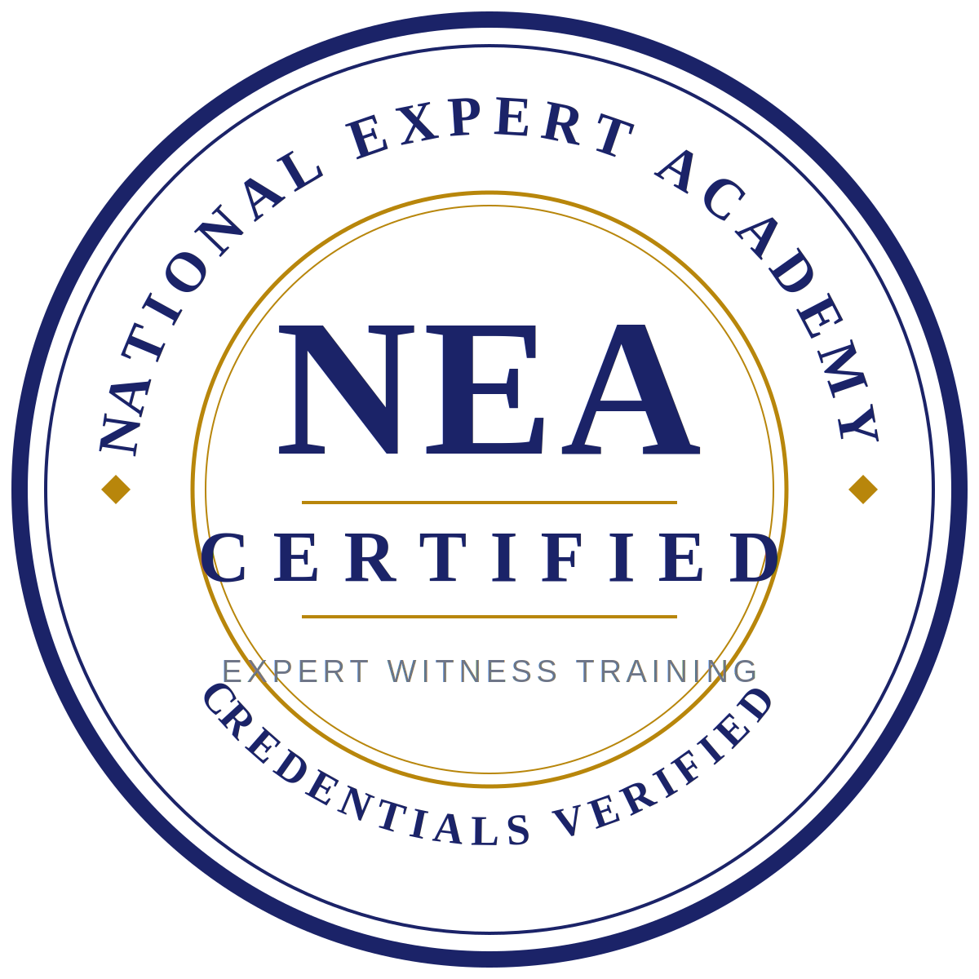
NEA CERTIFIED · NATIONAL EXPERT ACADEMY
National Expert Academy (NEA) is an independent third-party organization providing training and credential-verification services to expert witnesses who enroll in its programs. The expert identified in this curriculum vitae is not an employee or agent of NEA or of Med Legal Pro LLC. The NEA Certified designation is not an endorsement of this expert or of any opinion, report, or testimony he or she may provide. It certifies only that this expert has completed NEA's training program and that the credentials presented herein have been verified against source documentation.

